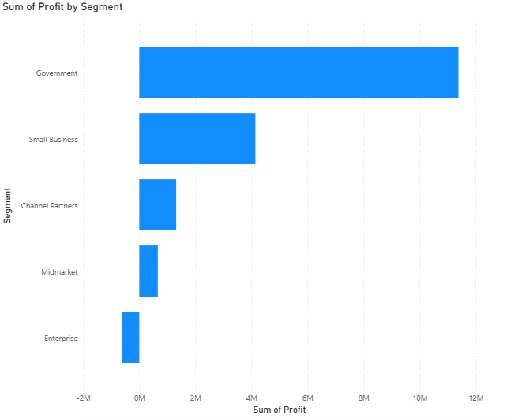

**QUESTION :**

What is the profit generated by different market segments?

**CHART TYPE :**

Stacked Bar Chart

**Y Axis** - Segment**, X Axis** - Sum of Profit

**INSIGHTS :**

1)The **Government** segment drives the highest profit, with a total of **₹1,13,88,173**.

2)**Small Business** is the second-highest profit segment, earning **₹41,43,168**.

3)**Channel Partners** generate less profit, totaling **₹13,16,803**.

4)**Midmarket** is the segment with the second-lowest profit, at **₹6,60,103**.

5)**Enterprise** does not generate profit; instead, it records a **loss of ₹6,14,545**.

**02/09/2025 POWER BI NOTES**

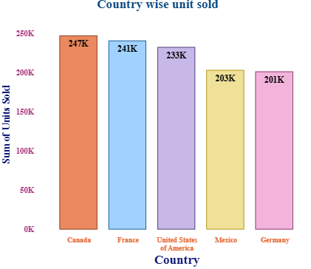

**Creating a Stacked Column Chart**

1. Use the default dataset in Power BI.
2. To create a **stacked column chart**, go to **Visualizations** and select the stacked column chart.
3. On the **X-axis**, place the **Country** field.
4. On the **Y-axis**, place the **Units Sold** field.
   * It will automatically change to **Sum of Units Sold**.

**Formatting Visualizations**

We can customize the chart in **Format Visual** to change the size, font, and other settings.

**X-axis**

* Values → Font style, Font size, Bold, Italic, Underline
* Color → Conditional formatting
* Maximum height

**Title**

* Title text
* Font → Font size, Bold, Italic, Underline
* Color → Conditional formatting

**Y-axis**

* Range → Minimum & Maximum (conditional)
* Values → Font style, Font size, Bold, Italic, Underline
* Color → Conditional formatting
* Display units (Thousands, Millions, Billions, Trillions)
* Value decimal places & size

**Gridlines**

* Horizontal gridlines → adjustable

**Zoom Slider**

* Enable zoom slider for better chart navigation

**Columns**

We can apply formatting to categories (all or selected):

* Change **Color** → Conditional formatting, Transparency
* Border → Color, Transparency, Width size

**Data Labels**

Apply settings to series (all or selected):

* Options → Orientation (horizontal or vertical)
* Position → Auto, Inside end, Outside end, Inside center, Inside base

**Values**

* Field name
* Font → Font style, Font size, Bold, Italic, Underline
* Color → Transparency
* Display units → Auto, Thousands, Millions, Billions, Trillions
* Value decimal places & size
* Show blank as (custom)

**Analytics**

* Y-axis constant line
* Error bars

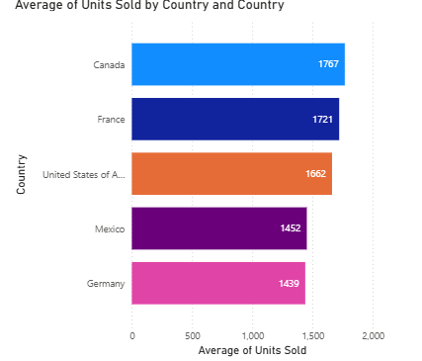

**Creating a Stacked Bar Chart**

1. To create a **stacked bar chart**, go to **Visualizations** and select the stacked column chart.
2. On the **X-axis**, place the **Country** field.
3. On the **Y-axis**, place the **Units Sold** field.
   * It will automatically change to **Average of Units Sold**.
4. If we want to apply multiple colors to the bars, we can use the Legend by placing the Country field in it, and the chart will automatically update

**Formatting Visualizations**

We can customize the chart in **Format Visual** to change the size, font, and other settings.

**X-axis**

* Values → Font style, Font size, Bold, Italic, Underline
* Color → Conditional formatting
* Maximum height

**Title**

* Title text
* Font → Font size, Bold, Italic, Underline
* Color → Conditional formatting

**Y-axis**

* Range → Minimum & Maximum (conditional)
* Values → Font style, Font size, Bold, Italic, Underline
* Color → Conditional formatting
* Display units (Thousands, Millions, Billions, Trillions)
* Value decimal places & size

**Gridlines**

* Horizontal gridlines → adjustable

**Zoom Slider**

* Enable zoom slider for better chart navigation

**Columns**

We can apply formatting to categories (all or selected):

* Change **Color** → Conditional formatting, Transparency
* Border → Color, Transparency, Width size

**Data Labels**

Apply settings to series (all or selected):

* Options → Orientation (horizontal or vertical)
* Position → Auto, Inside end, Outside end, Inside center, Inside base

**Values**

* Field name
* Font → Font style, Font size, Bold, Italic, Underline
* Color → Transparency
* Display units → Auto, Thousands, Millions, Billions, Trillions
* Value decimal places & size
* Show blank as (custom)

**Product wise sales**

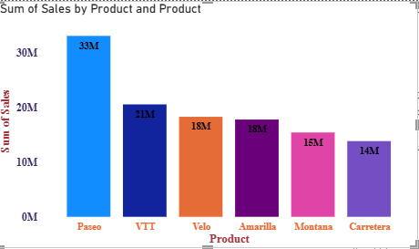

**Creating a Stacked Column Chart**

1. To create a **stacked column chart**, go to **Visualizations** and select the stacked column chart.
2. On the **X-axis**, place the **Product** field.
3. On the **Y-axis**, place the **Sales** field.
   * It will automatically change to **Sum of Sales**.
4. If we want to apply multiple colors to the bars, we can use the Legend by placing the Product field in it, and the chart will automatically update

**Formatting Visualizations**

We can customize the chart in **Format Visual** to change the size, font, and other settings.

**X-axis**

* Values → Font style, Font size, Bold, Italic, Underline
* Color → Conditional formatting
* Maximum height

**Title**

* Title text
* Font → Font size, Bold, Italic, Underline
* Color → Conditional formatting

**Y-axis**

* Range → Minimum & Maximum (conditional)
* Values → Font style, Font size, Bold, Italic, Underline
* Color → Conditional formatting
* Display units (Thousands, Millions, Billions, Trillions)
* Value decimal places & size

**Gridlines**

* Horizontal gridlines → adjustable

**Zoom Slider**

* Enable zoom slider for better chart navigation

**Columns**

We can apply formatting to categories (all or selected):

* Change **Color** → Conditional formatting, Transparency
* Border → Color, Transparency, Width size

**Data Labels**

Apply settings to series (all or selected):

* Options → Orientation (horizontal or vertical)
* Position → Auto, Inside end, Outside end, Inside center, Inside base

**Values**

* Field name
* Font → Font style, Font size, Bold, Italic, Underline
* Color → Transparency
* Display units → Auto, Thousands, Millions, Billions, Trillions
* Value decimal places & size
* Show blank as (custom)

**Product wise Profit**

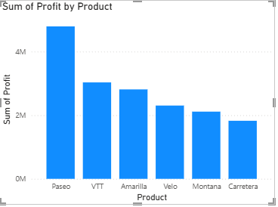

**Creating a Stacked Column Chart**

1. To create a **stacked column chart**, go to **Visualizations** and select the stacked column chart.
2. On the **X-axis**, place the **Product** field.
3. On the **Y-axis**, place the **Profit** field.
   * It will automatically change to **Sum of Profit**.

**Product wise Unit sold**

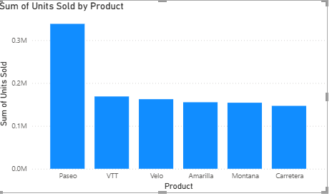

**Creating a Stacked Column Chart**

1. To create a **stacked column chart**, go to **Visualizations** and select the stacked column chart.
2. On the **X-axis**, place the **Product** field.
3. On the **Y-axis**, place the **Unit sold** field.
   * It will automatically change to **Sum of Unit sold**.

**Product wise Sales and Profit**

1. On the **X-axis**, place the **Product** field.
2. On the **Y-axis**, place the **Sales and Profit** field.
   * It will automatically change to **Sum of Sales and Sum of Profit**.

To create ,

**stacked column chart, stacked bar chart, clustered bar chart, clustered column chart, 100% stacked column chart, 100% stacked bar chart**

